Known Issues

Labels:
Priority: low/medium/high
Severity: Showstopper/Critical/Major/Minor/Cosmetic

Issue #1: User cannot transact in website (problem_user)

Steps to reproduce:
- Go to saucedemo website
- Login as problem_user credentials
- Errors are random, try the following:
  - Sorting is not working
  - Adding products to cart
  - Viewing products
  - Completing checkout

Actual result: random error encountered with user
Expected result: should be able to transact like standard_user

Priority: High
Severity: Showstopper/Blocker
Module: Account

Screenshots:
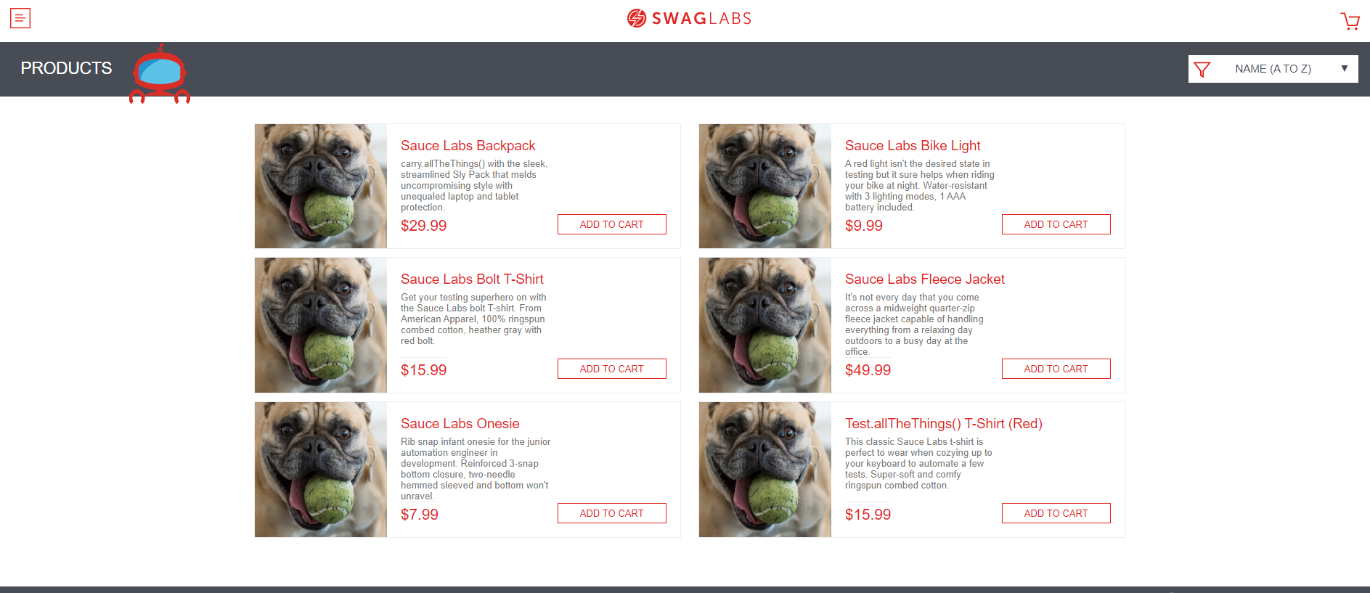
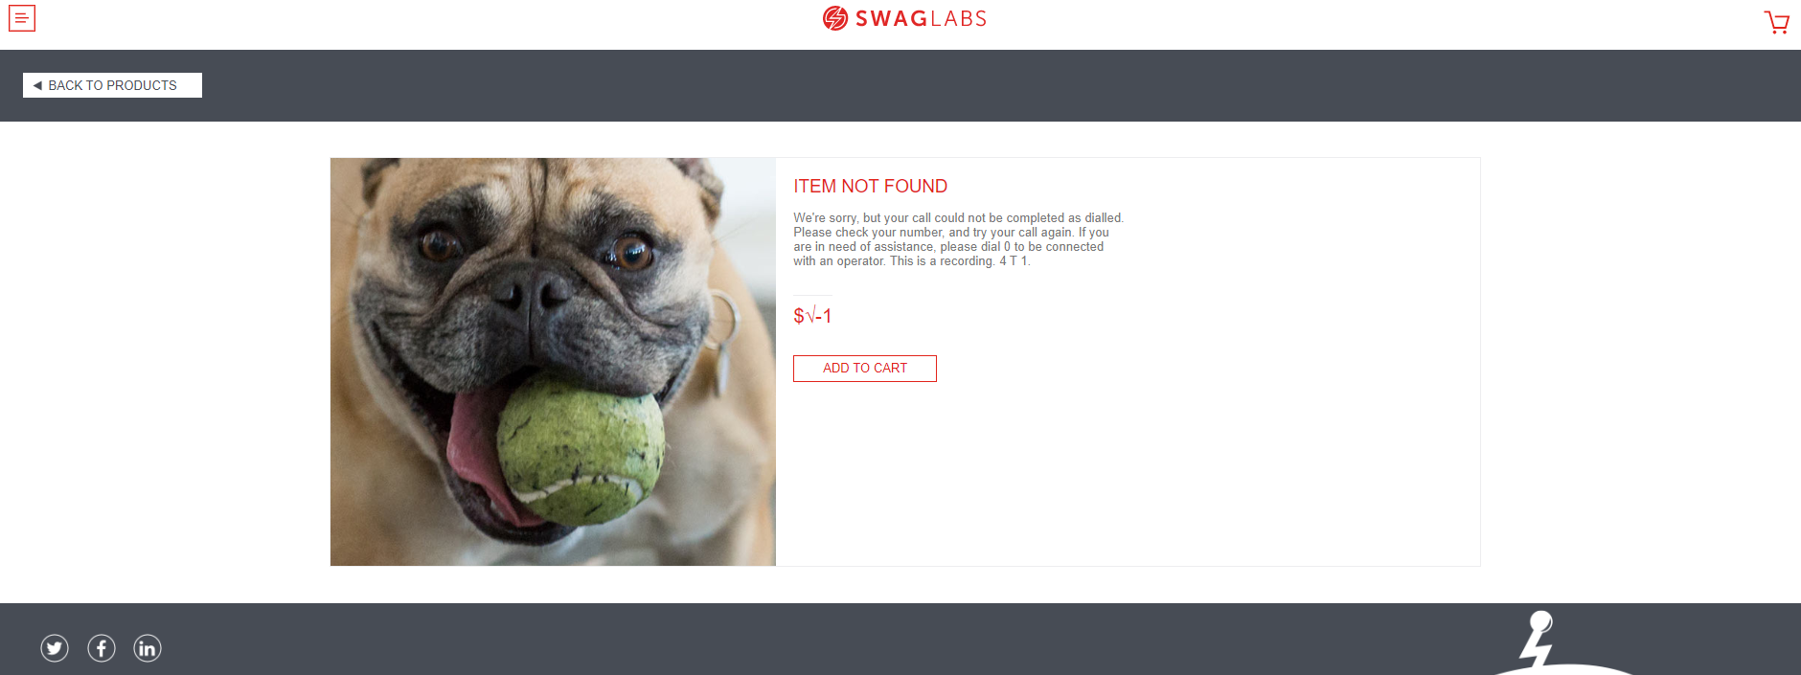
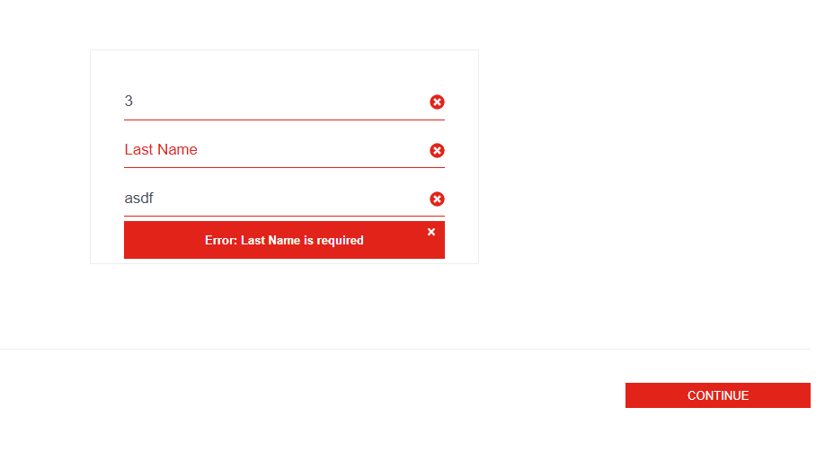

Issue #2: Reset app state removes items from cart but not updating products realtime

Steps to reproduce:
- Go to saucedemo website
- Login as standard_user credentials
- Add product to card
- Go to menu > reset app state

Actual Result: Product’s action buttons remain ‘Remove’
Expected result: Product’s action buttons should reset to ‘Add to cart’

Priority: Medium
Severity: Major
Module: Menu

Screenshots:
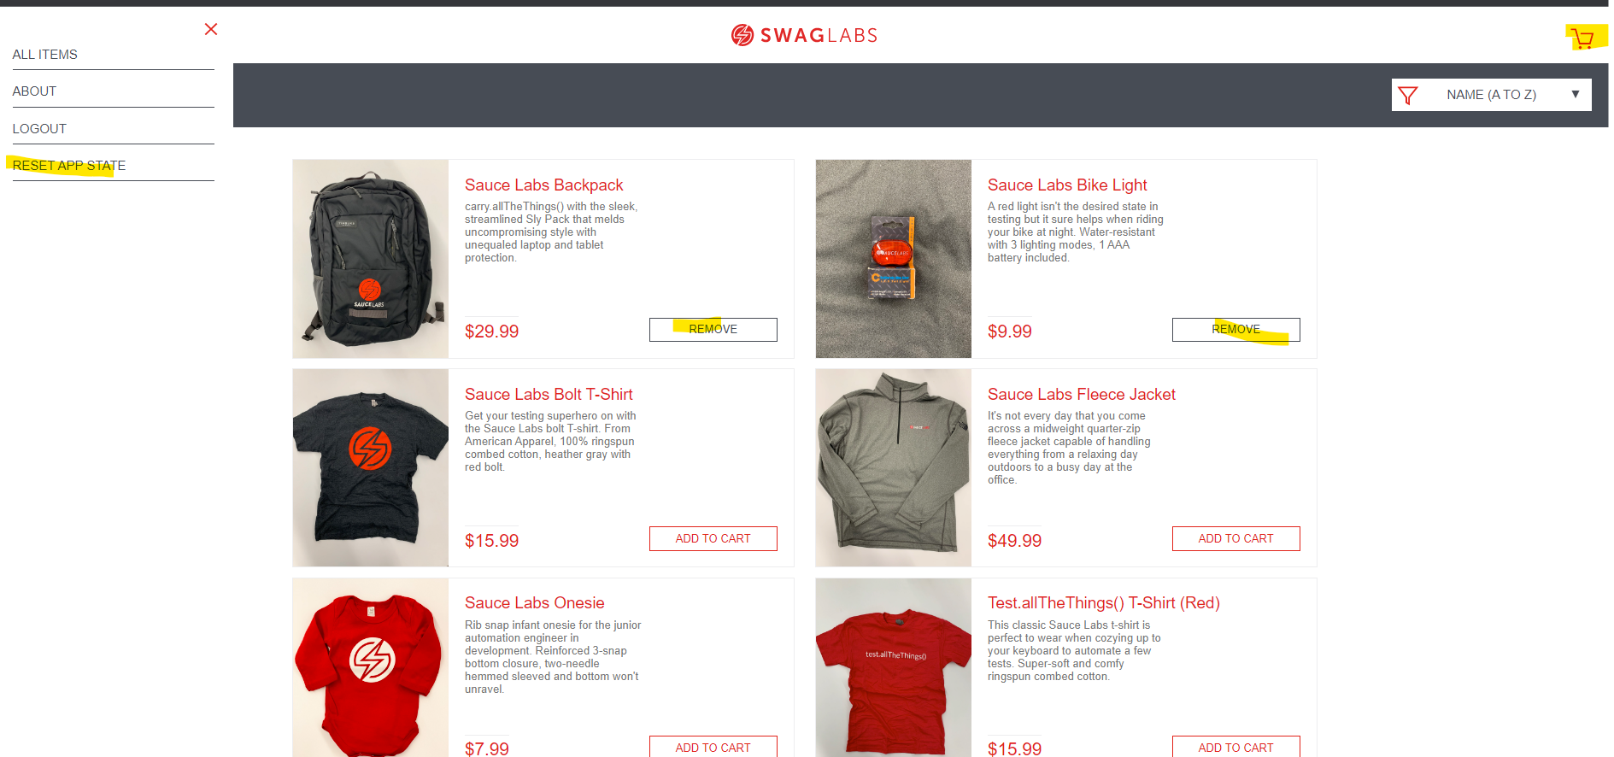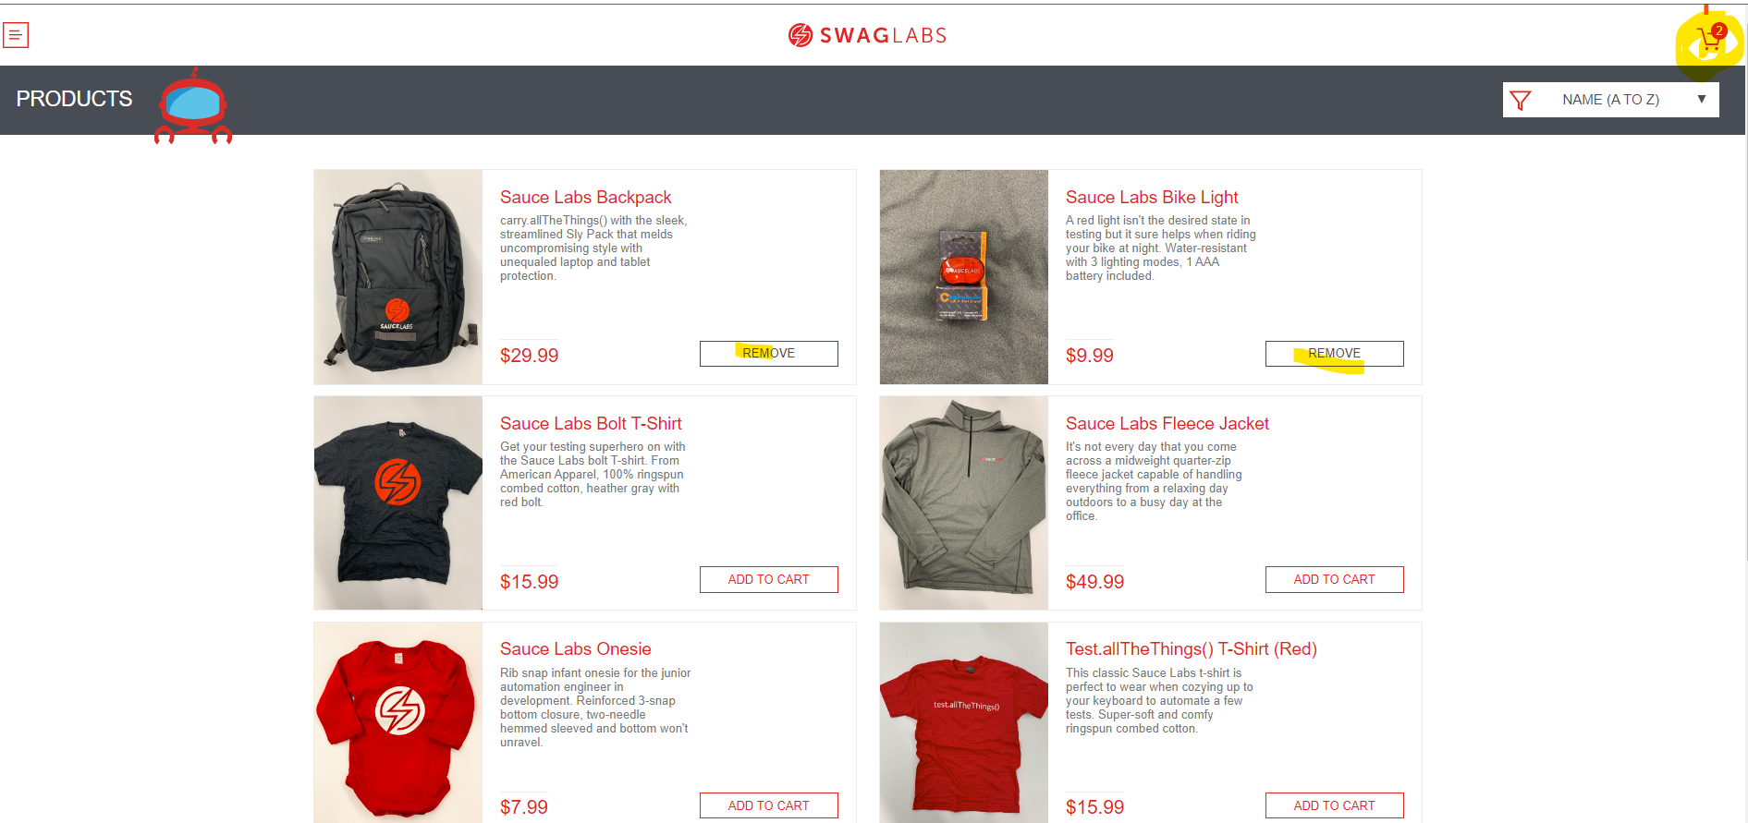

Issue #3: Checkout without an item in cart

Steps to reproduce:
- Go to saucedemo website
- Login as standard_user credentials
- Go to shopping cart without any added products
- Checkout shopping cart

Actual Result: Able to checkout empty cart
Expected Result: Validation to check empty cart

Priority: High
Severity: Critical
Module: Transaction

Screenshots:
